**Practical-7: Plugins with their properties**

**Definition:** Create a design using various plugins in Figma, like iconify, Unsplash, gradient and wave plugins.

**Solution:**

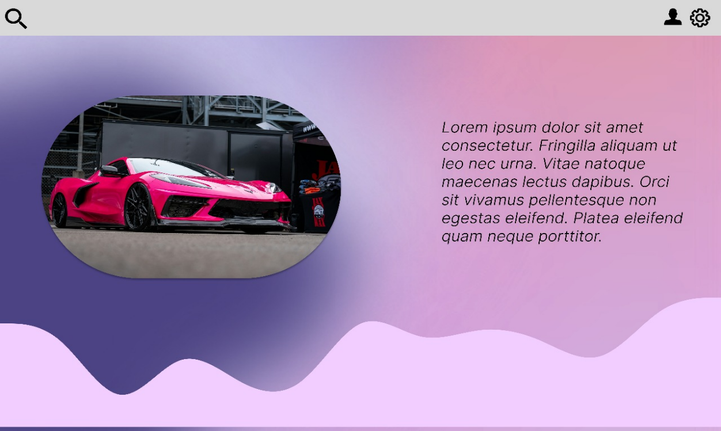

**Working:**

* First, open Figma. Add a new Figma design file.
* Rename a file as Practical-7.
* In this design, the following tools are used for a particular operation:

|  |  |  |
| --- | --- | --- |
| **Tool Name** | **Use** | **Properties / Settings** |
| Frame Tool (F) | Create the full canvas background | Size: 1194 x 768 px Fill: Linear Gradient (Left → Right) From #A9A9F5 to #E6A9EC |
| Rectangle Tool (R) | Top navigation bar (gray area) | Size: 1194 x 50 px Fill: #E0E0E0 Position: Y = 0 No stroke |
| Icon Import | Top-left search icon | Use Figma Community → search: "search icon" Size: 30 x 30 px Position: X = 10, Y = 10 |
| Icon Import | Top-right profile & settings icons | Use Figma Community → search: "user icon" and "gear icon" Size: 30 x 30 px each Align to top right using horizontal auto layout |
| Ellipse Tool (O) | Create the oval car image mask | Size: 450 x 300 px Use oval shape OR rectangle with Corner Radius = 150 px Right-click > “Use as mask” |
| Image Fill | Insert car image | Drag & drop from computer or use Fill > Image Use mask technique above to clip image to oval shape |
| Drop Shadow | Add shadow to the oval car image | Effect: Drop Shadow X: 0, Y: 4, Blur: 12 Color: #00000033 (20% opacity) |
| Text Tool (T) | Add the lorem ipsum paragraph | Font: Roboto Italic Font Size: 20 px Line Height: 28 px Color: #000000 @ 70% opacity Width: Max 380 px |
| Pen Tool (P) or Plugin | Create the wave shape at the bottom of screen | Use Pen tool manually OR use Figma Plugin (search: "Wave Shape") Fill color: #EECFFC Place at bottom of the frame |
| Auto Layout (Shift+A) | Use for grouping top right icons or managing spacing easily | Use horizontal layout Spacing between icons: 10 px |
| Align Tool | Position and align all items properly | Use top bar Align tools → Align Center, Left, Right etc. Keep items centered and visually balanced |

* Export your design as a PNG file.